

ANSIBLE HANS-ON
DevOps Certification Training

support@intellipaat.com
+91-7022374614
US: 1-800-216-8930(Toll Free)

ANSIBLE HANDS-ON
Ansible hands-on documentation has been divided into 3 segments.
A. Creating Ansible Playbook
B. Creating Ansible Roles
C. Using Ansible Roles in Playbook

Prerequisites:
- Ansible needs to be installed in master.
- Connection between Master and Host needs to be set through ssh. For more information refer to the Ansible Installation Documentation.

A- Creating Ansible Playbook
This playbook consists of two plays with following tasks:
- Play 1: Execute a command in host1, Execute a script in host1
- Play 2: Execute a script in host2, Install nginx in host2
Step 1: Create the .yml file.
sudo nano <playbookname>

Step 2: Add the following content in the .yml file.
---
- hosts: host1
sudo: yes
name: Play 1
tasks:
- name: Execute command ‘Date’
command: date
- name: Execute script on server
script: test_script.sh
- hosts: host2
name: Play 2
sudo: yes
tasks:
- name: Execute script on server
script: test_script.sh
- name: Install nginx
apt: name=nginx state=latest

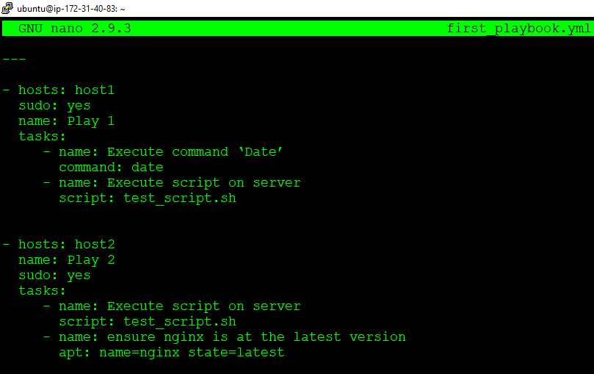

Step 3: Now to be able to perform “Execute script on server” task we need to have the .sh file (unix (linux) shell executables files) in master machine. Create test.sh file as shown.
sudo nano <file_name>

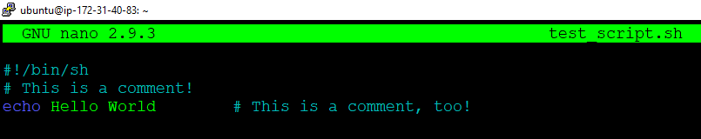
Step 4: Before executing the playbook that we just created we need to have to check for syntax errors.
ansible-playbook <playbook> --syntax-check
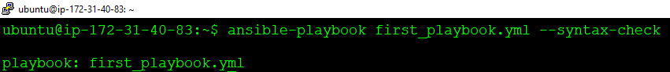
This means our playbook is syntax error free. Let us move ahead and execute the playbook.

Step 5: To execute the playbook use the following command.
ansible-playbook <playbook>

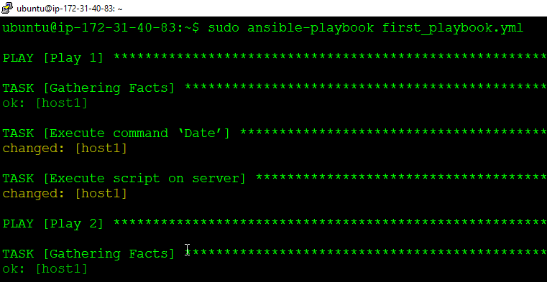
Great! We have successfully created our very first Ansible playbook.
Remember that using playbook we can run the same command repeatedly, but if everything was configured on the first run, then all subsequent runs make no changes.
B- Creating Ansible Roles
Step 1: Ansible roles should be written inside “/etc/ansible/roles/ ”. Use the following command to create one Ansible role.
ansible-galaxy init <role name> --offline
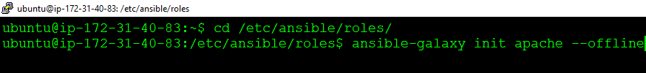

Step 2: Install tree package using sudo apt install tree. Use tree command to view structure of the role
sudo apt install tree

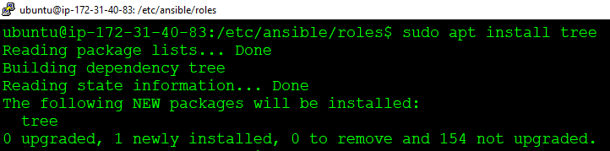
Now let us see the structure of the role that we just created using the following command.
tree <role name>

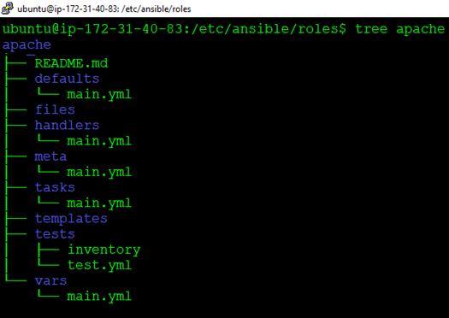
Now we are ready to create the tasks that our roles are supposed to perform.

Step 3: Go inside task folder inside apache directory. Edit main.yml using the following command. Make changes as shown. Save and then exit.
sudo nano main.yml

Now we will divide the tasks to be performed into three categories. Install, configure and services. We will create three different .yml files to reduce the complexity. Include those separate task files in the main.yml file as shown.
---
# tasks file for apache
- include: install.yml
- include: configure.yml
- include: service.yml

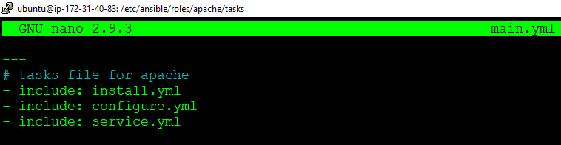
Remember that order of the list in yml file matters. So here install.yml gets executed first, then configure.yml and then service.yml.

Step 4: Now inside task folder, create install.yml and add the installation tasks to be performed as shown below.
sudo nano install.yml

We will install the latest version of apache2 in the remote machine with the help of apt module as shown below.
---
- name: install apache2
apt: name=apache2 update_cache=yes state=latest
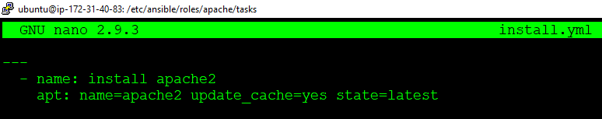

Step 5: Then create configure.yml and add the required configurations that need to be performed on remote machine as shown below.
sudo nano configure.yml

We will configure apache2.conf file in the remote machine and also, we will restart the apache2 service. Then we will send one file from /etc/ansible/roles/apache/files folder to the remote machine. The destination path has been set to /home/ubuntu/ as shown.
--
#configure apache2.conf and send copy.html file
- name: apache2.conf file
copy: src=apache2.conf dest=/etc/apache2/
notify:
- restart apache2 service

- name: send copy.html file
copy: src=copy.html dest=/home/ubuntu/

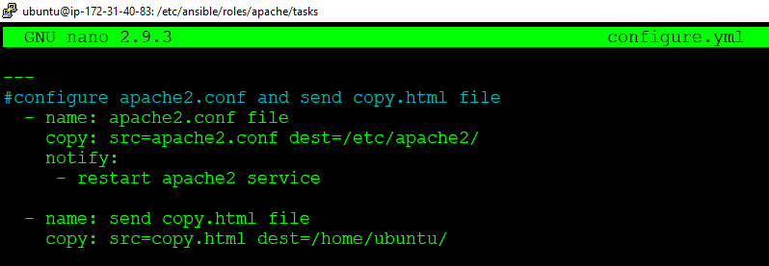

Step 6: Again, inside task folder, create service.yml and add the required configurations that need to be performed on remote machine as shown below.
sudo nano service.yml

We will configure apache2.conf file in the remote machine
---
- name: starting apache2 service
service: name=apache2 state=started

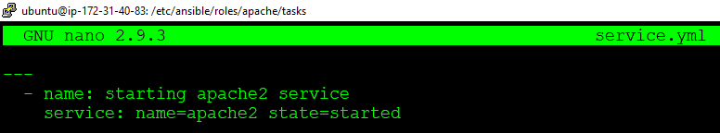

Step 7: Now, Now go inside files. Store the files that needs to be pushed to the remote machine. Copy the apache2.conf file from /etc/apache2 directory to /etc/ansible/roles/apache/files and create the html file.
cp /etc/apache2/apache2.conf /etc/ansible/roles/apache/files

Create one html file as well. My dummy html file looks like this.
<html>
<title> Some File </title>
<body> <h1> Copy This File> </h1> </body>
</html>

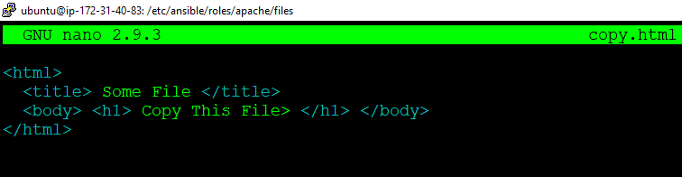
Check whether our files are ready or not by using the following command.
ls

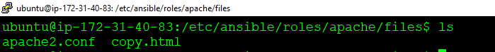

Step 8: Go inside handlers and add the action that needs to be performed after notify from configure.yml is executed. Use the following two commands.
cd /etc/ansible/roles/apache/handlers/
sudo nano main.yml

Add the following content inside handlers file.
---
# handlers file for apache
- name: restart apache2 service
service: name=apache2 state=restarted

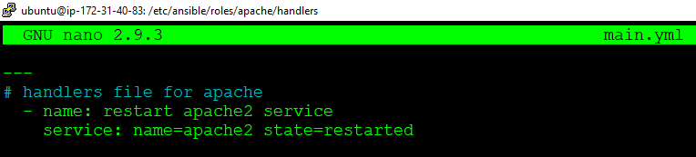
Remember that notify name and handler name should match.
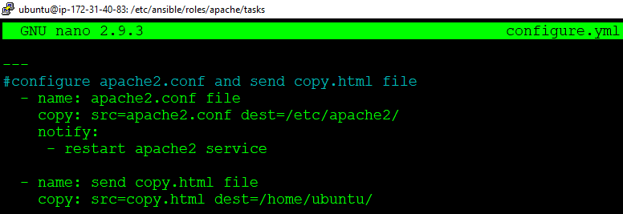



Step 9: Go inside meta and add information related to the role.
cd /etc/ansible/roles/apache/handlers/
sudo nano main.yml

Add author information, role descriptions, company information etc. as shown below.
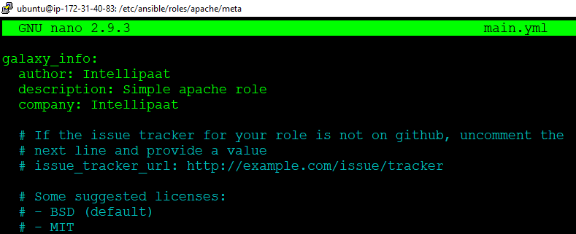

Step 10: Go to the /etc/ansible/ and create one top level .yml file where we can add hosts and roles to be executed. Execute apache role on the hosts that is under the group name servers, added in the inventory file /etc/ansible/hosts
cd /etc/ansible/
sudo nano site.yml

For more than one hosts following commands can be used.
---
- hosts: servers
sudo: yes
roles:
- apache

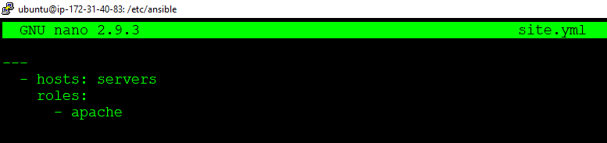

Step 11: Before we execute our top level yml file we will check for syntax errors.
ansible-playbook <filename.yml> --syntax-check

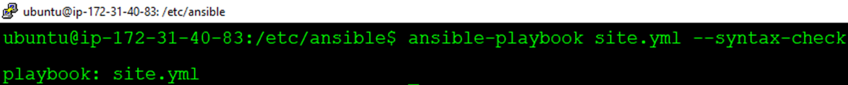
put our configuration in there as shown below.
Step 12: Execute the top level .yml file
ansible-playbook <filename.yml>

The output looks like this.
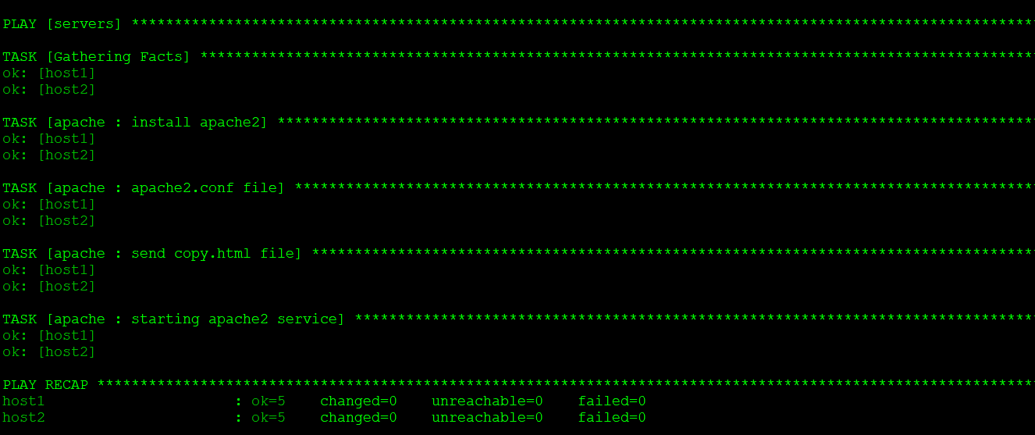
Congratulations! You have successfully created Ansible Role.
Now let us see how to use this Ansible role that we’ve just created along with other tasks in a Ansible Playbook.
C- Using Ansible Roles in Playbook
Step 1: To use ansible roles along with other tasks in playbook use import_role and include_role. Create one playbook called to execute on the remote machines along with two debug tasks before and after apache role.
sudo nano <playbook name>

Add the following .yml file as shown.
---
- hosts: servers
sudo: yes
tasks:
- debug:
msg: "before we run our role"
- import_role:
name: apache
- include_role:
name: apache
- debug:
msg: "after we ran our role"

Step 2: Check for syntax error and execute the playbook with roles.
ansible-playbook <playbookname> --syntax-check

Step 3: Check for syntax error and execute the playbook with roles.
ansible-playbook <playbookname>

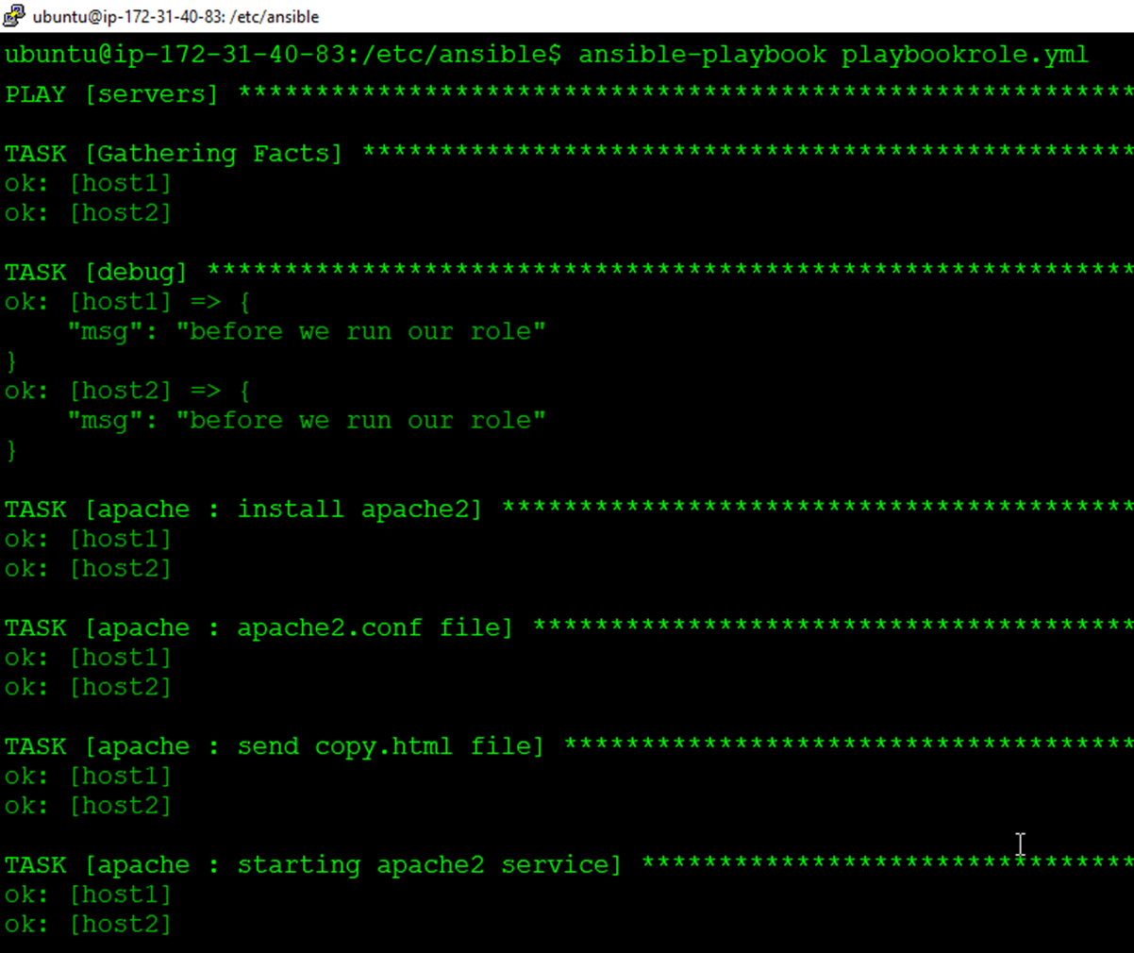
Congratulations! You have successfully integrated Ansible roles with Ansible playbook.

